.

**Mathematical Foundations**

**Problem Statements**

Q1) Find the maximum and minimum values of the function: x^3 - 3x^2 - 9x + 12

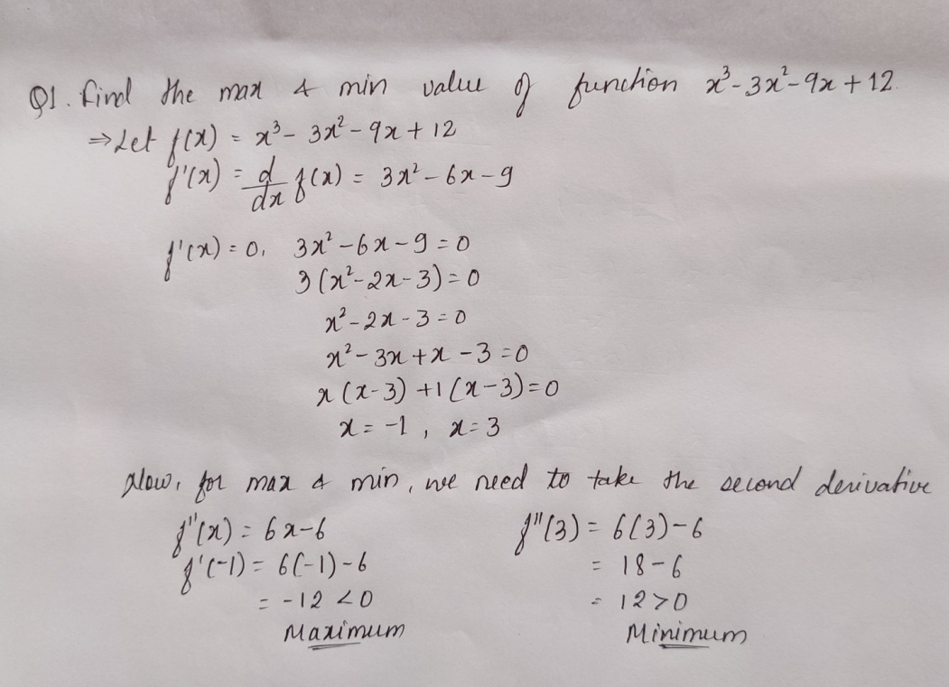

Q2) Calculate the slope and the equation of a line which passes through the points (-1, -1) (3, 8)

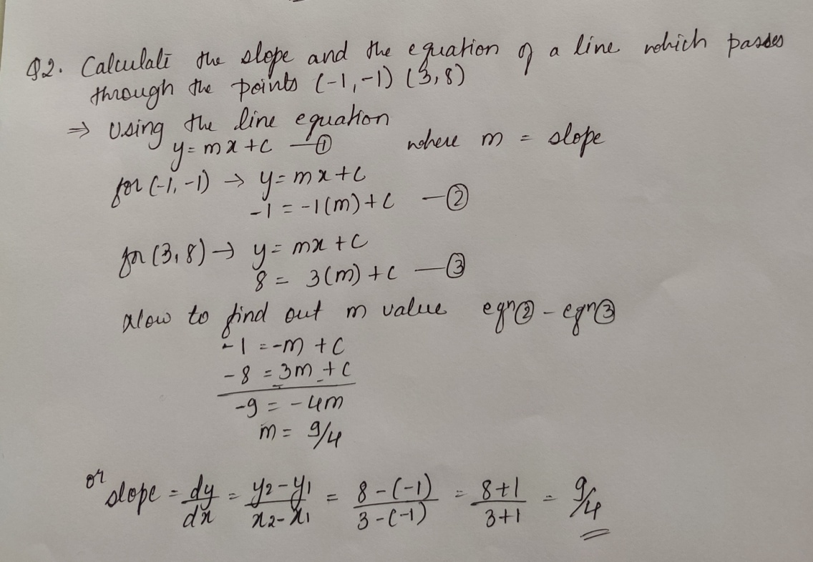

Q3) Solve for w’(z) when



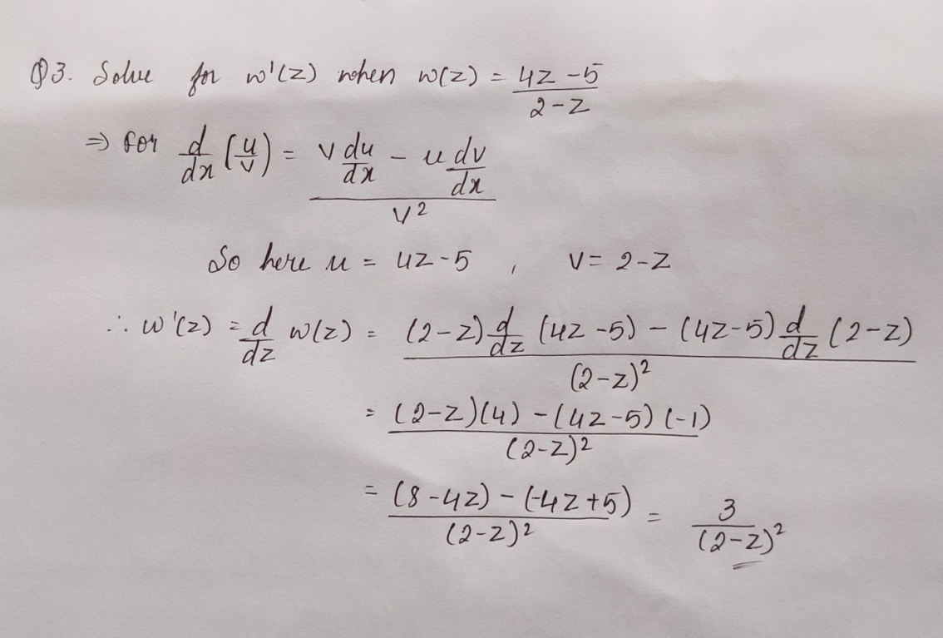

Q4) Consider Y(x)= 2x^3+6x^2+3x. Identify the critical values and verify if it is the maxima or minima.

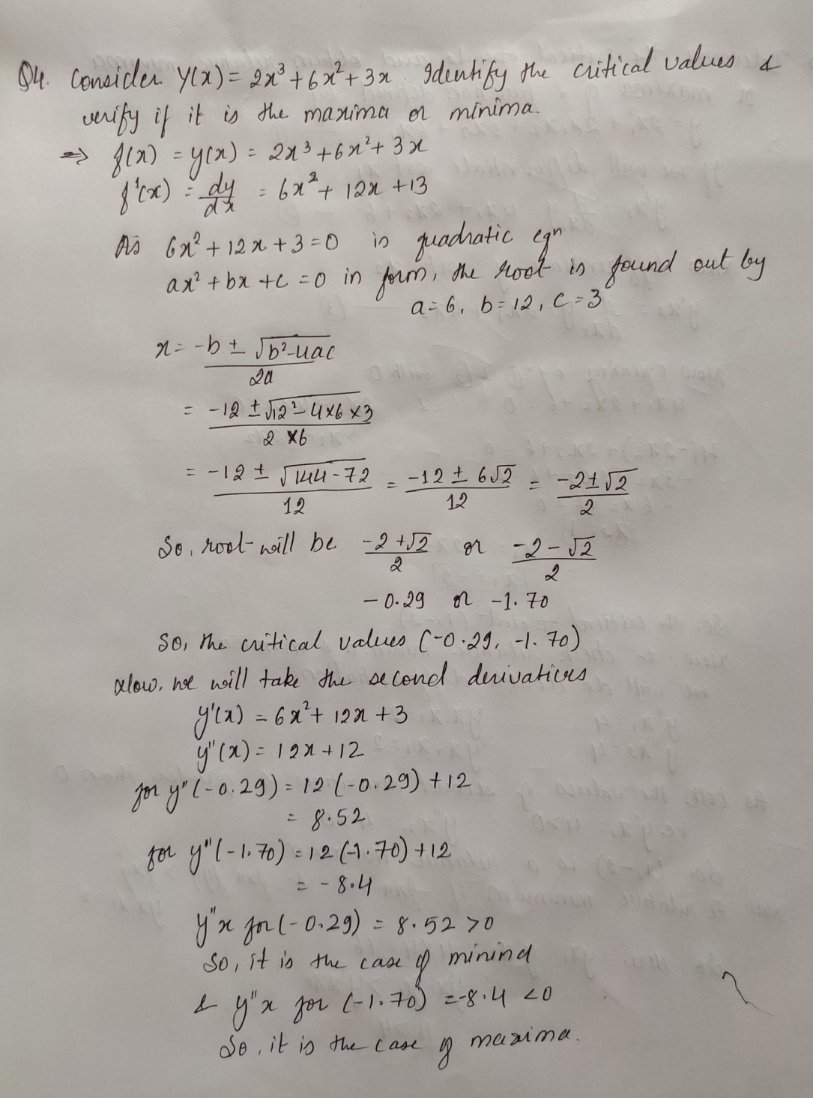

Q5) Determine the critical points and obtain relative minima or maxima of a function defined by



